1. Write the equation in general form.
​
a.
b.
c.
d.
e.

ANSWER: | c

2. Write the equation in general form.
​
a.
b.
c.
d.
e.

ANSWER: | a

3. Solve the equation .
​
a.
b.
c.
d.
e.

ANSWER: | e

4. Solve the equation by factoring.
​
a.
b.
c.
d.
e.

ANSWER: | b

5. Solve the equation by using the quadratic formula. Give real solutions only.
​
​
 | a.
 | b.
 | c.
 | d. | no real solutions
 | e.

ANSWER: | d

6. Solve the equation by using the quadratic formula. Give real answers rounded to two decimal places.
​
​
a.
b.
c.
d.
e.

ANSWER: | a

7. Find the exact real solutions to the equation, if they exist.
​
​
 | a.
 | b.
 | c.
 | d.
 | e. | no real solutions

ANSWER: | d

8. Find the exact real solutions to the equation, if they exist.
​
​
a.
b.
c.
d.
e.

ANSWER: | a

9. Find the exact real solutions of the equation , if they exist.
​
 | a. | and
 | b. | and
 | c. | and
 | d. | and
 | e. | and

ANSWER: | b

10. Find the exact real solutions of the equation 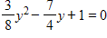, if they exist.
​
 | a. | and
 | b. | and
 | c. | and
 | d. | and
 | e. | and

ANSWER: | d

11. Find the exact real solutions of the equation , if they exist.
​
 | a. | and
 | b. | and
 | c. | and
 | d. | and
 | e. | Real solutions do not exist.

ANSWER: | b

12. Solve the equation by using a graphing utility.
​
​
a.
b.
c.
d.
e.

ANSWER: | a

13. Solve the equation by using a graphing utility. Round your answers to two decimal places.
​
 | a. | and
 | b. | and
 | c. | and
 | d. | and
 | e. | and

ANSWER: | c

14. Multiply both sides of the equation 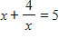by the LCD, and then solve the resulting quadratic equation.
​
a.
b.
c.
d.
e.

ANSWER: | a

15. Solve the equation 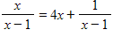by first multiplying by the LCD, and then solving the resulting equation.
​
a.
b.
c.
d.
e.

ANSWER: | d

16. Solve the equation below using quadratic methods.
​
​
a.
b.
c.
d.
e.

ANSWER: | d

17. If the profit from the sale of x units of a product is , what level(s) of production will yield a profit of $1,000?
​
 | a. | less 15 units of production.
 | b. | more than 80 units of production.
 | c. | 95 units of production.
 | d. | 65 units of production.
 | e. | 15 or 80 units of production.

ANSWER: | e

18. If a ball is thrown upward at 80 feet per second from the top of a building that is 100 feet high, the height of the ball can be modeled by , where t is the number of seconds after the ball is thrown. How long after it is thrown is the height 100 feet?

 | a. | seconds
 | b. | seconds
 | c. | seconds
 | d. | seconds
 | e. | seconds

ANSWER: | a

19. The amount of airborne particulate pollution p from a power plant depends on the wind speed s, among other things, with the relationship between p and s approximated by . Find the value of s that will make .
​
a.
b.
c.
d.
e.

ANSWER: | c

20. The sensitivity S to a drug is related to the dosage size by , where x is the dosage size in milliliters. Determine all dosages that yield 0 sensitivity.
​
 | a. | milliliters, milliliters
 | b. | milliliters, milliliters
 | c. | milliliters, milliliters
 | d. | milliliters, milliliters
 | e. | milliliters

ANSWER: | b

21. The time t, in seconds, that it takes a 2005 Corvette to accelerate to x mph can be described by 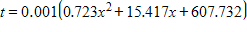. How fast is the Corvette going after 9.08 seconds? Give your answer to the nearest tenth.
​
 | a. | 97.1 mph
 | b. | 98.1 mph
 | c. | ​100.1 mph
 | d. | ​118.9 mph
 | e. | ​119.4 mph

ANSWER: | b

22. Suppose that the percent of total personal income that is used to pay personal taxes is given by , where x is the number of years past 1990 (Source: Bureau of Economic Analysis, U.S. Department of Commerce). Find the year or years when the percent of total personal income used to pay personal taxes is 18 percent.
​
 | a. | 2013
 | b. | 2003
 | c. | ​2002
 | d. | ​2008
 | e. | ​2044

ANSWER: | b

23. A fissure in the earth appeared after an earthquake. To measure its vertical depth, a stone was dropped into it, and the sound of the stone's impact was heard 3.3 seconds later. The distance (in feet) the stone fell is given by , and the distance (in feet) the sound traveled is given by . In these equations, the distances traveled by the sound and the stone are the same, but their times are not. Using the fact that the total time is 3.3 seconds, find the depth of the fissure. Round your answer to two decimal places.
​
 | a. | 94.19 feet
 | b. | 91.00 feet
 | c. | 121.98 feet
 | d. | 126.38 feet
 | e. | 126.48 feet

ANSWER: | c

24. An equation that models the number of users of the Internet is million users, where x is the number of years past 1990 (Source: CyberAtlas, 1999). If the pattern indicated by the model remains valid, when does this model predict there will be 1,100 million users?
​
 | a. | 2004
 | b. | 2021
 | c. | 2014
 | d. | 2007
 | e. | 2005

ANSWER: | e

25. The model for body-heat loss depends on the coefficient of convection K, which depends on wind speed v according to the equation where v is in miles per hour. Find the positive coefficient of convection when the wind speed is 29 mph. Round your answer to the nearest integer.
​
a.
b.
c.
d.
e.

ANSWER: | b

26. Find the vertex of the graph of the equation .
​
a.
b.
c.
d.
e.

ANSWER: | d

27. Determine if the vertex of the graph of the equation is a maximum or minumim point.
​
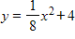
​
 | a. | vertex is at a maximum point
 | b. | vertex is at a minimum point
 | c. | has no vertex

ANSWER: | b

28. Find the vertex of the graph of the equation . Round your answer to two decimal places.
​
a.
b.
c.
d.
e.

ANSWER: | a

29. Determine what value of x gives the optimal value of the function, and determine the optimal (maximum or minimum) value. Round your answers to two decimal places.
​
​
 | a. | optimal value of x: 0, optimal value: 1.00
 | b. | optimal value of x: –1.13, optimal value: 0.75
 | c. | optimal value of x: 1.50, optimal value: –1.50
 | d. | optimal value of x: –0.75, optimal value: –1.13
 | e. | optimal value of x: 0.75, optimal value: –1.13

ANSWER: | e

30. Determine whether the function’s vertex is a maximum point or a minimum point and find the coordinates of this point.
​
​
 | a. | vertex: , a minimum point
 | b. | vertex: , a maximum point
 | c. | vertex: , a minimum point
 | d. | vertex: , a maximum point
 | e. | vertex: , a maximum point

ANSWER: | a

31. Sketch the graph of the following function.
​
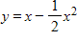
​
 | a. | ​ | b. | ​  ​
 | c. | ​  ​ | d. | ​  ​
 | e. | ​

ANSWER: | a

32. Find the zeros, if any exist. Round your answers to two decimal places.
​
​
 | a. | zeros at –2.17 and –7.83
 | b. | zeros at 0 and 10.00
 | c. | zeros at 11.00 and –21.00
 | d. | no zeros
 | e. | zeros at 0 and 27.00

ANSWER: | a

33. Determine whether the vertex of the graph of the following function is a maximum point or a minimum point. Also find the coordinates of the vertex.
​
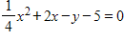
​
 | a. | vertex: , a maximum point
 | b. | vertex: , a minimum point
 | c. | vertex: , a minimum point
 | d. | vertex: , a minimum point
 | e. | vertex: , a maximum point

ANSWER: | b

34. Find the x-intercepts, if any exist. Round your answers to two decimal places.
​
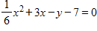
​
 | a. | x-intercepts: ,
 | b. | x-intercepts: ,
 | c. | x-intercepts: ,
 | d. | x-intercepts: ,
 | e. | no x-intercepts

ANSWER: | c

35. How is the graph of shifted to obtain the graph of the function ?
​
 | a. | shifted 12 units to the left and 13 units up
 | b. | shifted 12 units to the right and 13 units down
 | c. | shifted 144 units to the left and 13 units up
 | d. | shifted 24 units to the right and 13 units down
 | e. | shifted 12 units to the right and 13 units up

ANSWER: | e

36. Use a graphing utility to find the vertex of the function. Round your answer to two decimal places.
​
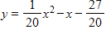
​
 | a. | vertex:
 | b. | vertex: origin
 | c. | vertex:
 | d. | vertex:
 | e. | vertex:

ANSWER: | a

37. Sketch the graph of the following function by using graphing calculator.
​
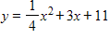
​
 | a. | ​ | b. | ​
 | c. | ​ | d. | ​
 | e. | ​

ANSWER: | d

38. Find the average rate of change of the function between the given values of x.
​
between and .
​​
 | a. | 15
 | b. | ​50
 | c. | ​0
 | d. | ​–6
 | e. | ​100

ANSWER: | c

39. Find the vertex and then determine the range of the function.
​
​
 | a. | all values greater than or equal to 67
 | b. | all values less than or equal to 63
 | c. | all values greater than or equal to 10
 | d. | all values less than or equal to 85
 | e. | all values less than or equal to 67

ANSWER: | e

40. Use a graphing utility to approximate the solutions to . Round your answers to two decimal places.
​
​
a.
b.
c.
d.
e.

ANSWER: | c

41. Factor the function .
​
a.
b.
c.
d.
e.

ANSWER: | c

42. Solve for the function .
​
 | a.
 | b.
 | c.
 | d.
 | e. | no real solutions

ANSWER: | d

43. The daily profit from the sale of a product is given by dollars. What level of production maximizes profit?
​
 | a. | production level of 100 units
 | b. | production level of 10 units
 | c. | production level of 5 units
 | d. | production level of 50 units
 | e. | production level of 95 units

ANSWER: | d

44. The daily profit from the sale of a product is given by dollars. What is the maximum possible profit? Round intermediate calculations and final answer to the nearest dollar.
​
 | a. | $1,701
 | b. | $2,613
 | c. | $808
 | d. | $95
 | e. | $185

ANSWER: | c

45. The daily profit from the sale of a product is given by dollars. What is the maximum possible profit? Round intermediate calculations and final answer to the nearest dollar.
​
 | a. | $5,423
 | b. | $16,685
 | c. | $11,013
 | d. | $137
 | e. | $271

ANSWER: | a

46. The yield in bushels from a grove of orange trees is given by , where x is the number of orange trees per acre. How many trees will maximize the yield?
​
 | a. | 1,500 trees
 | b. | 3,000 trees
 | c. | 800 trees
 | d. | 1,550 trees
 | e. | 750 trees

ANSWER: | e

47. The sensitivity S to a drug is related to the dosage x in milligrams by . Use a graphing utility to determine what dosage gives maximum sensitivity.
​
 | a. | 97
 | b. | 235,225
 | c. | 970, 0
 | d. | 970
 | e. | 485

ANSWER: | e

48. A ball thrown vertically into the air has its height above ground given by , where t is in seconds and s is in feet. Find the maximum height of the ball.
​
 | a. | 242 feet
 | b. | 121 feet
 | c. | 8 feet
 | d. | 16 feet
 | e. | 229 feet

ANSWER: | e

49. The owner of a skating rink rents the rink for parties at $912 if 76 or fewer skaters attend, so that the cost per person is $12 if 76 attend. For each 5 skaters above 76, she reduces the price per skater by $0.50. Which table gives the revenue generated if 76, 86, and 96 skaters attend?
​
 | a. | ​  Price No. of skaters Total Revenue  12 76 $960  11 86 $946  10 96 $912 | b. | ​  Price No. of skaters Total Revenue  12 76 $912  13 86 $946  14 96 $960
 | c. | ​  Price No. of skaters Total Revenue  12 76 $912  11 86 $946  10 96 $960 | d. | ​  Price No. of skaters Total Revenue  12 76 $912  13 86 $1118  14 96 $1344
 | e. | ​  Price No. of skaters Total Revenue  12 76 $912  11.5 86 $989  11 96 $1056

ANSWER: | a

50. When a stone is thrown upward, it follows a parabolic path given by a form of the equation . If represents ground level, find the equation of a stone that is thrown from ground level at and lands on the ground 130 units away if the stone reaches a maximum height of 130 units.
​
a.
b.
c.
d.
e.

ANSWER: | b

51. In 1995, America’s 45 million Social Security recipients received a 2.6% cost-of-living increase, the second smallest increase in nearly 20 years, a reflection of lower inflation. The percent increase might be described by the function , where t is the number of years past 1980. In what year does the model predict the highest cost of living percent increase?
​
 | a. | 1990
 | b. | 2009
 | c. | 1987
 | d. | 1989
 | e. | none of the above

ANSWER: | d

52. Sketch the first quadrant portions of the following functions and estimate the market equilibrium point.
​
Supply: 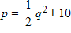
Demand:
​
 | a. | ​  ​ | b. | ​  ​
 | c. | ​  ​ | d. | ​  ​
 | e. | ​  ​

ANSWER: | b

53. A supply function has the equation is 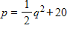, and the demand function is decribed by the equation . Algebraically determine the equilibrium point for the supply and demand functions. Round your answer to two decimal places.
​
a.
b.
c.
d.
e.

ANSWER: | d

54. If the supply function for a commodity is and the demand function is , find the equilibrium quantity and equilibrium price. Round your final answer to two decimal places.
​
a.
b.
c.
d.
e.

ANSWER: | e

55. If the supply and demand functions for a commodity are given by and , respectively, find the price that will result in market equilibrium.
​
 | a. | 41
 | b. | 150
 | c. | 33
 | d. | 31
 | e. | 25

ANSWER: | c

56. If the supply and demand functions for a commodity are given by and , what is the equilibrium price and what is the corresponding number of units supplied and demanded? Round your answer to two decimal places.
​
a.
b.
c.
d.
e.

ANSWER: | a

57. The supply function for a product is , while the demand function for the same product is . Find the market equilibrium point E(q, p). Round your final answer to two decimal places.
​
a.
b.
c.
d.
e.

ANSWER: | d

58. The supply function for a product is , while the demand function for the same product is . If a $22 tax is placed on production of the item, then the supplier passes this tax on by adding $22 to his selling price. Find the new equilibrium point E(q, p) for this product when the tax is passed on. (The new supply function is given by 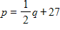.) Round your final answer to two decimal places.
​
a.
b.
c.
d.
e.

ANSWER: | d

59. The total costs for a company are given by , and the total revenues are given by . Find the break-even points.
​
 | a. | Break-even values are at x = 35 and x = 70 units.
 | b. | Break-even values are at x = inf units.
 | c. | Break-even values are at x = -inf units.
 | d. | Break-even values are at x = 17.5 and x = 35 units.
 | e. | Break-even values are at x = 70 units.

ANSWER: | a

60. If a firm has the following cost and revenue functions, find the break-even points.
​
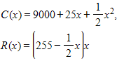
​
 | a. | Break-even values are at and units.
 | b. | Break-even values are at and units.
 | c. | Break-even values are at and units.
 | d. | Break-even values are at and units.
 | e. | Break-even values are at and units.

ANSWER: | e

61. If a company has total costs , and total revenues given by , find the break-even points. Round your answers to two decimal places.
​
 | a. | Break-even values are at and units.
 | b. | Break-even values are at and units.
 | c. | Break-even values are at and units.
 | d. | Break-even values are at units.
 | e. | Break-even values are at and units.

ANSWER: | b

62. If total costs are and total revenues are , find the break-even points.
​
 | a. | Break-even values are at and units.
 | b. | Break-even values are at and units.
 | c. | Break-even values are at and units.
 | d. | Break-even values are at and units.
 | e. | Break-even values are at and units.

ANSWER: | b

63. Given the profit function, , and that production is restricted to fewer than 75 units, find the break-even point(s). Round your answer to two decimal places.
​
 | a. | Break-even value is at units.
 | b. | Break-even value is at units.
 | c. | Break-even value is at units.
 | d. | Break-even value is at units.
 | e. | Break-even value is at units.

ANSWER: | e

64. Find the maximum revenue for the revenue function . Round your answer to the nearest cent.
​
 | a. | $84,008.93
 | b. | $252,026.79
 | c. | $48,005.10
 | d. | $216,022.96
 | e. | $253,026.79

ANSWER: | a

65. If, in a monopoly market, the demand for a product is , and the revenue function is , where x is the number of units sold, what price will maximize revenue? Round your answer to the nearest cent.
​
 | a. | Price that will maximize revenue is .
 | b. | Price that will maximize revenue is .
 | c. | Price that will maximize revenue is .
 | d. | Price that will maximize revenue is .
 | e. | Price that will maximize revenue is .

ANSWER: | a

66. The profit function for a certain commodity is . Find the level of production that yields maximum profit, and find the maximum profit.
​
 | a. | Production levels of 110 yields a maximum profit of $1,200.
 | b. | Production levels of 110 yields a maximum profit of $1,825.
 | c. | Production levels of 55 yields a maximum profit of $4,795.
 | d. | Production levels of 55 yields a maximum profit of $3,025.
 | e. | Production levels of 55 yields a maximum profit of $1,825.

ANSWER: | e

67. Use a graphing calculator to graph the profit function .
​
 | a. | ​  ​ | b. | ​
 | c. | ​ | d. | ​
 | e. | ​

ANSWER: | e

68. The graph of the profit function is given as follows. Consider the average rate of change of the profit from a to 400 where a lies to the left of 400. Does the average rate of change of the profit get closer to 0 or farther from 0 as a gets closer to 400?
​
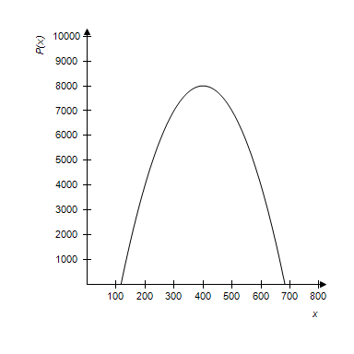
​
 | a. | closer to 0
 | b. | farther from 0

ANSWER: | a

69. Form the profit function for the cost and revenue functions, where the total costs and total revenues are given by and .
​
a.
b.
c.
d.
e.

ANSWER: | b

70. Suppose a company has fixed costs of $26,000 and variable costs of 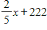dollars per unit, where x is the total number of units produced. Suppose further that the selling price of its product is 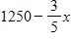dollars per unit. Find the break-even points. Round your answer to the nearest cent.
​
 | a. | Break-even values are at and .
 | b. | Break-even values are at and .
 | c. | Break-even values are at and .
 | d. | Break-even values are at and .
 | e. | Break-even values are at and .

ANSWER: | a

71. Suppose a company has fixed costs of $27,000 and variable costs of dollars per unit, where x is the total number of units produced. Suppose further that the selling price of its product is 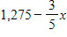 dollars per unit. Find the maximum revenue. Round your answer to the nearest cent.
​
 | a. | Maximum revenue is $1,026.70.
 | b. | Maximum revenue is $27,000.00.
 | c. | Maximum revenue is $26,862.50.
 | d. | Maximum revenue is $677,343.75.
 | e. | Maximum revenue is $612.50.

ANSWER: | d

72. Assume that sales revenues for Continental Divide Mining can be described by , where t is the number of years past 1992. Use the function to determine the year in which maximum revenue occurs.
​
 | a. | Maximum revenue occurred during 1998.
 | b. | Maximum revenue occurred during 1992.
 | c. | Maximum revenue occurred during 1997.
 | d. | Maximum revenue occurred during 2003.
 | e. | Maximum revenue occurred during 1991.

ANSWER: | c

73. Assume that sales revenues, in millions, for Continental Divide Mining can be described by , where t is the number of years past 1992. Use the function to find the maximum revenue. Round your answers to three decimal places.
​
 | a. | Maximum revenue is $9.463 million.
 | b. | Maximum revenue is $5.971 million.
 | c. | Maximum revenue is $3.672 million.
 | d. | Maximum revenue is $3.851 million.
 | e. | Maximum revenue is $16.986 million.

ANSWER: | d

74. Assume that costs and expenses for Continental Divide Mining can be described by and the sales revenue can be described by , where t is the number of years since the beginning of 1992. Find the year in which maximum profit occurs.
​
 | a. | 2014
 | b. | 1993
 | c. | 2003
 | d. | 2004
 | e. | 1994

ANSWER: | c

75. Sketch the graph of the function .
​
 | a. | ​ | b. | ​
 | c. | ​ | d. | ​
 | e. | ​

ANSWER: | c

76. Sketch the graph of the function .
​
 | a. | ​ | b. | ​
 | c. | ​ | d. | ​
 | e. | ​

ANSWER: | a

77. Sketch the graph of the function .
​
 | a. | ​ | b. | ​
 | c. | ​ | d. | ​
 | e. | ​

ANSWER: | e

78. Sketch the graph of the function below.
​
​
 | a. | ​ | b. | ​
 | c. | ​ | d. | ​
 | e. | ​

ANSWER: | b

79. Sketch the graph of the function .
​
 | a. | ​ | b. | ​
 | c. | ​ | d. | ​
 | e. | ​

ANSWER: | d

80. Sketch the graph of the function 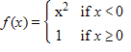.
​
 | a. | ​ | b. | ​
 | c. | ​ | d. | ​
 | e. | ​

ANSWER: | b

81. Sketch the graph of the function 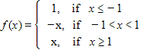.
 | a. | ​ | b. | ​
 | c. | ​  ​ | d. | ​
 | e. | ​

ANSWER: | d

82. By recognizing shapes and features of polynomial functions, sketch the graph of the function . Use a graphing utility to confirm your graph.
​
 | a. | ​ | b. | ​
 | c. | ​ | d. | ​
 | e. | ​

ANSWER: | c

83. By recognizing shapes and features of polynomial functions, sketch the graph of the function . Use a graphing utility to confirm your graph.
​
 | a. | ​ | b. | ​
 | c. | ​ | d. | ​
 | e. | ​

ANSWER: | e

84. By recognizing shapes and features of rational functions, sketch the graph of the function 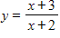. Use a graphing utility to confirm your graph.
​
 | a. | ​ | b. | ​
 | c. | ​ | d. | ​
 | e. | ​

ANSWER: | a

85. Find the rational function whose graph is given.
​
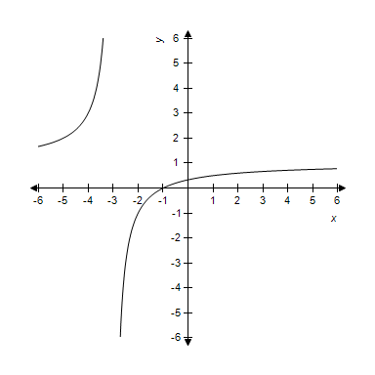
​
a.
b.
c.
d.
e.

ANSWER: | d

86. If , find and . Round your answers to two decimal places.
​
 | a. | and ​
 | b. | and
 | c. | and
 | d. | and
 | e. | and

ANSWER: | a

87. 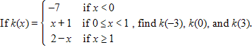
​
a.
b.
c.
d.
e.

ANSWER: | c

88. Determine whether the given graph is the graph of a polynomial function, a rational function (but not a polynomial), or a piecewise defined function. Use the graph to estimate the turning points. Round your answers to two decimal places.
​
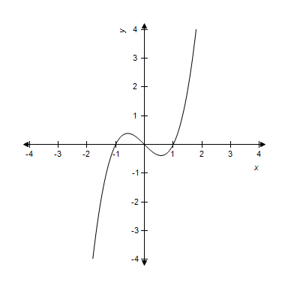
​
 | a. | polynomial function  turning points: and
 | b. | rational function  turning points: and
 | c. | polynomial function  turning points: , , and
 | d. | rational function  turning points: , , and
 | e. | piecewise function  turning points: and

ANSWER: | a

89. Determine whether the given graph is the graph of a polynomial function, a rational function (but not a polynomial), or a piecewise defined function. Use the graph to estimate the turning points and any asymptotes.
​
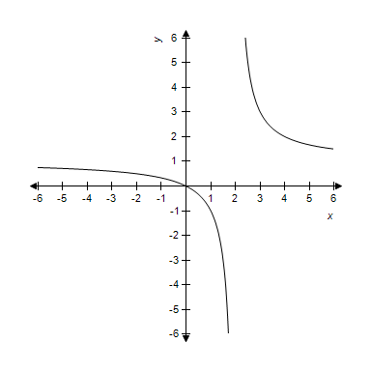
​
 | a. | polynomial function  turning points:  vertical asymptote:  horizontal asymptote:
 | b. | rational function  turning points: none  vertical asymptote:  horizontal asymptote:
 | c. | rational function  turning points: none  vertical asymptote:  horizontal asymptote:
 | d. | piecewise function  turning points:  vertical asymptote:  horizontal asymptote:
 | e. | polynomial function  turning points: none  vertical asymptote:  horizontal asymptote:

ANSWER: | b

90. Determine whether the given graph is the graph of a polynomial function, a rational function (but not a polynomial), or a piecewise defined function. Use the graph to estimate the turning points.
​
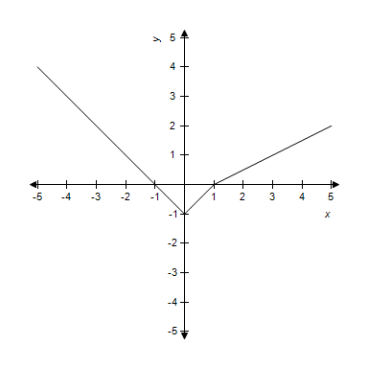
​
 | a. | piecewise function  turning points: and
 | b. | polynomial function  turning points: and
 | c. | rational function  turning points:
 | d. | polynomial function  turning points:
 | e. | piecewise function  turning points:

ANSWER: | e

91. An open-top box is constructed from a square piece of cardboard with sides of length 9 ft. The volume of such a box is given by , where x is the height of the box. Find the volume of the box if its height is 4 ft.
​
 | a. | 2.5 ft³
 | b. | 3.5 ft³
 | c. | 4 ft³
 | d. | 6 ft³
 | e. | 8.5 ft³

ANSWER: | c

92. The amount of money invested in a certain mutual funds, measured in millions of dollars, for the years 1995 to 1999 was found to be modeled by million dollars, where x is the number of years past 1990. Will the graph of this function bend upward or will it bend downward? How much money is predicted to be in the fund in the year 2009? Round your answer to two decimal places.
​
 | a. | the function's graph bends upward; the function predicts 134,947.08 million dollars in 2009
 | b. | the function's graph bends downward; the function predicts 134,947.08 million dollars in 2009
 | c. | the function's graph bends upward; the function predicts 68,279.14 million dollars in 2009
 | d. | the function's graph bends downward; the function predicts 1,611.20 million dollars in 2009
 | e. | the function's graph bends upward; the function predicts 1,611.20 million dollars in 2009

ANSWER: | d

93. Suppose that the cost C (in dollars) of removing p percent of the particulate pollution from the smokestacks of an industrial plant is estimated by 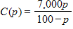. What is the domain of this function? What will it cost to remove 99.1% of the particulate pollution? Round your answer to the nearest cent.
​
 | a. | domain:  cost: $770,777.78
 | b. | domain:  cost: $770,777.78
 | c. | domain: all p except p = 100  cost: $770,777.78
 | d. | domain:  cost: $70.06
 | e. | domain: all p except p = 100  cost: $70.06

ANSWER: | b

94. The monthly charge for water in a small town is given by 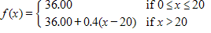, where x is water usage in hundreds of gallons and f (x) is cost in dollars. Find the monthly charge for 1900 gallons and for 2600 gallons. Round your answers to the nearest cent.
​
 | a. | charge for 1900 gallons is $36.00  charge for 2600 gallons is $38.40
 | b. | charge for 1900 gallons is $788.00  charge for 2600 gallons is $1068.00
 | c. | charge for 1900 gallons is $36.00  charge for 2600 gallons is $46.40
 | d. | charge for 1900 gallons is $38.40  charge for 2600 gallons is $46.40
 | e. | charge for 1900 gallons is $36.00  charge for 2600 gallons is $74.40

ANSWER: | a

95. A shipping company's charges for delivery of a package is a function of the package's weight. The following table describes the company's shipping rates.
​
Weight Increment | Rate
First pound or fraction of a pound | $0.65
Each additional pound or fraction of a pound | $1.10
​
Convert this table to a piecewise defined function that represents shipping costs for packages weighing between 0 and 4 pounds using x as the weight in pounds and C as the cost in dollars. Find the postage for a 1.25-pound package. Round your answer to the nearest cent.
​
 | a. | cost for a 1.25 lb package: $1.30  ​
 | b. | cost for a 1.25 lb package: $1.36  ​
 | c. | cost for a 1.25 lb package: $2.03  ​
 | d. | cost for a 1.25 lb package: $1.75  ​
 | e. | cost for a 1.25 lb package: $2.03  ​

ANSWER: | d

96. The demand function for a product is given by 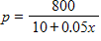, where x is the number of units and p is the price in dollars. Graph this demand function for , with x on the horizontal axis.
​
 | a. | ​ | b. | ​
 | c. | ​ | d. | ​
 | e. | ​  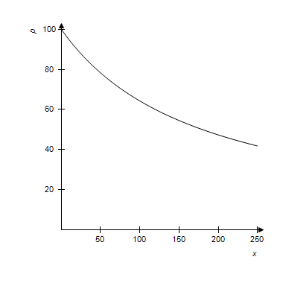

ANSWER: | c

97. The demand function for a product is given by 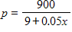, where x is the number of units and p is the price in dollars. The graph of this demand function for , with x on the horizontal axis is given below. Does the demand function ever reach 0?
​
 | a. | Yes
 | b. | No

ANSWER: | No

98. The given graph shows the cost C, in thousands of dollars, of a production run for a product when x machines are used. Estimate the company's fixed cost of production to the nearest thousand dollars, and determine the number of machines that will result in maximum cost for the company.
​
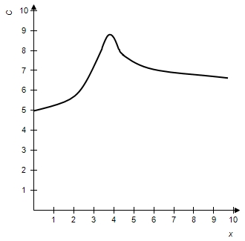
​
 | a. | fixed production cost: $6,000  maximum cost when 4 machines used
 | b. | fixed production cost: $9,000  maximum cost when 4 machines used
 | c. | fixed production cost: $5,000  maximum cost when 4 machines used
 | d. | fixed production cost: $6,000  maximum cost when 6 machines used
 | e. | fixed production cost: $5,000  maximum cost when 6 machines used

ANSWER: | c

99. Determine whether the scatter plot should be modeled by a linear, power, quadratic, cubic, or quartic function.
​
​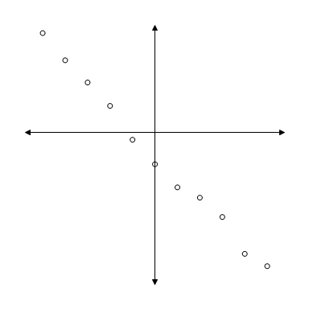
​
 | a. | linear
 | b. | power
 | c. | quadratic
 | d. | cubic
 | e. | quartic

ANSWER: | a

100. Determine whether the scatter plot should be modeled by a linear, power, quadratic, cubic, or quartic function.
​
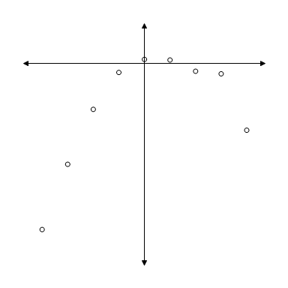
​
 | a. | linear
 | b. | power
 | c. | quadratic
 | d. | cubic
 | e. | quartic

ANSWER: | c

101. Determine whether the scatter plot should be modeled by a linear, power, quadratic, cubic, or quartic function.
​
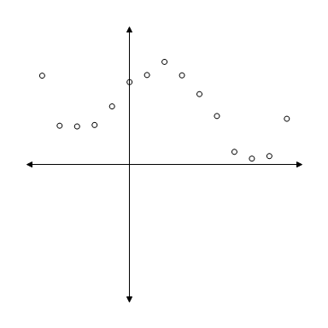
​
 | a. | linear
 | b. | power
 | c. | quadratic
 | d. | cubic
 | e. | quartic

ANSWER: | e

102. Determine whether the scatter plot should be modeled by a linear, power, quadratic, cubic, or quartic function.
​
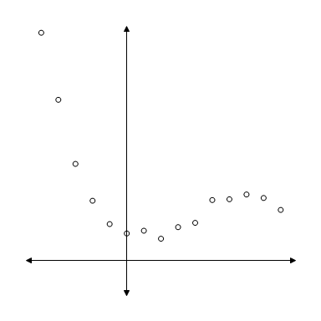
​
 | a. | linear
 | b. | power
 | c. | quadratic
 | d. | cubic
 | e. | quartic

ANSWER: | d

103. Find the equation of the linear function that is the best fit for the given data. Round your final values to two decimal places.
​
x | y
0 | 3.5
1 | 5.6
2 | 7.1
3 | 9.6
4 | 11.5
​
a.
b.
c.
d.
e.

ANSWER: | b

104. Graph the linear function that models the data given in the table below.
​
x | –1 | 0 | 1 | 2 | 3 | 4 | 5
y | –1.5 | –1.0 | –0.5 | 0.0 | 0.5 | 1.0 | 1.5

 | a. | ​ | b. | ​
 | c. | ​ | d. | ​
 | e. | ​

ANSWER: | a

105. Find the equation of the quadratic function that is the best fit for the given data. Round your final values to two decimal places.
​
x | y
–2 | –3.26
–1 | –3.42
0 | –2.20
1 | 2.50
2 | 8.98
3 | 19.04
4 | 31.08

a.
b.
c.
d.
e.

ANSWER: | e

106. Graph the quadratic function that models the data given in the table below.
​
x | –4 | –3 | –2 | –1 | 0 | 1 | 2
y | –8 | –5 | –4 | –5 | –8 | –13 | –20

 | a. | ​ | b. | ​
 | c. | ​ | d. | ​
 | e. | ​

ANSWER: | b

107. Find the equation of the cubic function that is the best fit for the given data. Round your final values to two decimal places.
​
x | y
–4 | –85.4
–3 | –37.6
–2 | –10.8
–1 | 0.6
0 | 3.1
1 | 4.4
2 | 10.8
​
a.
b.
c.
d.
e.

ANSWER: | b

108. Graph the cubic function that models the data given in the table below.
​
x | –3 | –2 | –1 | 0 | 1 | 2 | 3
y | 14 | –2 | –6 | –4 | –2 | –6 | –22

 | a. | ​ | b. | ​
 | c. | ​ | d. | ​
 | e. | ​

ANSWER: | c

109. Find the equation of the quartic function that is the best fit for the given data. Round your final values to two decimal places.
​
x | y
1 | 2.3
2 | 56.9
3 | 256.4
4 | 750.3
5 | 1742.4
6 | 3489.9
7 | 6303.6
​
a.
b.
c.
d.
e.

ANSWER: | a

110. Graph the power function that models the data given in the table below.
​
x | 1 | 2 | 3 | 4 | 5 | 6
y | 3.0000 | 8.4853 | 15.5885 | 24.0000 | 33.5410 | 44.0908
​
 | a. | ​ | b. | ​
 | c. | ​ | d. | ​
 | e. | ​

ANSWER: | b

111. Determine what type of function best models the data given below, and find the equation that is the best fit for the data. Round your final values to four decimal places.
​
x | y
0 | 2.38
1 | 9.48
2 | 16.44
3 | 23.45
4 | 30.32
5 | 37.46
6 | 44.47
​
 | a. | linear;
 | b. | quadratic;
 | c. | power;
 | d. | cubic;
 | e. | quartic;

ANSWER: | a

112. Determine what type of function best models the data given below, and find the equation that is the best fit for the data. Round your final values to four decimal places.
​
x | y
0 | 7.8
1 | 40.1
2 | 59.7
3 | 66.3
4 | 59.7
5 | 40.4
6 | 7.7
​​
 | a. | linear;
 | b. | quadratic;
 | c. | power;
 | d. | cubic;
 | e. | quartic;

ANSWER: | b

113. The table shows the average earnings of year-round, full-time workers by gender and educational attainment in a certain country. Let x represent earnings for males and y represent earnings for females, and find a linear model that expresses women’s annual earnings as a function of men’s. Interpret the slope of the linear model. Round your final values to three decimal places.
​
Educational Attainment | Average Annual Earnings

 | Males | Females
Less than 9th grade | $11,270 | $10,750
Some high school | $12,430 | $11,450
High school graduate | $19,640 | $17,205
Some college | $20,875 | $11,370
Associate’s degree | $24,270 | $22,070
Bachelor’s degree or more | $39,335 | $28,505

 | a. | slope: females earn $1,296 for each $1,000 males earn
 | b. | slope: the average difference in yearly male and female earnings is $1,296
 | c. | slope: females earn $652 for each $1,000 males earn
 | d. | slope: the average difference in yearly male and female earnings is $652
 | e. | slope: the average of male and female earnings increases by an average of $652 for each level of educational attainment

ANSWER: | c

114. The table gives the median household income (in 2005 year) for two cities in various years. Let x represent the median household income for citizens of city A and y represent the corresponding median household income for citizens of city B. Find a linear model that expresses the median household income for citizens in city B as a function of the median household income for citizens of city B. Interpret the slope of the linear model. Round numerical values in your answer to three decimal places.
Median Household Income
(2005 year)
Year | City A | City B
1985 | $21,900 | $19,600
1990 | $23,800 | $21,500
1995 | $25,700 | $24,500
2000 | $27,400 | $27,200
2005 | $31,000 | $31,100

 | a. | slope: median household income is growing at the same rate for city A as it is for city B.
 | b. | slope: median household income is growing at the same rate for city A as it is for city B.
 | c. | slope: median household income is growing at the same rate for city A as it is for city B.
 | d. | slope: median household income is growing faster for city A than it is for city B.
 | e. | slope: median household income is growing slower for city A than it is for city B.

ANSWER: | d

115. Suppose the IQ scores (rounded to the nearest 10) for a group of people are summarized in the table below. Find the quadratic function that best fits the data, using x as the IQ score and y as the number of people in the group with that IQ score. Use a graphing utility to estimate the IQ score of the maximum number of individuals according to the model. Round your final answer to 2 decimal places.
​
IQ Score | Number of People
70 | 47
80 | 72
90 | 93
100 | 88
110 | 75
120 | 51
130 | 13

 | a. | The model predicts that the maximum number of people have an IQ score of approximately 96.
 | b. | The model predicts that the maximum number of people have an IQ score of approximately 90.
 | c. | The model predicts that the maximum number of people have an IQ score of approximately 90.
 | d. | The model predicts that the maximum number of people have an IQ score of approximately 96.
 | e. | The model predicts that the maximum number of people have an IQ score of approximately 90.

ANSWER: | a

116. Suppose that the following table gives the number of near-collisions on the runways of the nation's airports. With representing 1990, find a quadratic function that models the data in the chart. Round numerical values in your answer to four decimal places. Depending on the technology you use, your answer may be slightly different than the correct answer shown.
​
Year | Runway near-hits in USA
1990 | 300
1991 | 312
1992 | 320
1993 | 325
1994 | 340
1995 | 365
1996 | 378
1997 | 420
1998 | 455
1999 | 481
2000 | 498

a.
b.
c.
d.
e.

ANSWER: | a

117. The table that follows gives the population of a city. Find the power function that best fits the data, with x equal to the number of years past 1950. According to the model, will the city's population be greater than 1,400 by the year 2010? Round your final answer to three decimal places.
Year | Population
1960 | 665
1970 | 853
1980 | 1,123
1990 | 1,148
2000 | 1,170

 | a. | The model predicts that the population will not be greater than 1,400.
 | b. | The model predicts that the population will not be greater than 1,400.
 | c. | The model predicts that the population will be greater than 1,400.
 | d. | The model predicts that the population will be greater than 1,400.
 | e. | The model predicts that the population will not be greater than 1,400.

ANSWER: | b

118. Suppose that the following table shows the number of millions of people in the United States who lived below the poverty level for selected years. Find a cubic model that approximately fits the data, using x as the number of years after 1960. Round numerical values in your answer to four decimal places. Depending on the technology you use, your answer may be slightly different than the correct answer shown.
​
Year | Persons Living Below the  Poverty Level (millions)
1960 | 87.3
1970 | 28.4
1975 | 25.6
1980 | 43.2
1989 | 97.6
1990 | 103.9
1992 | 100.8
1996 | 120.4
2000 | 140.6
2002 | 138.4

a.
b.
c.
d.
e.

ANSWER: | d

119. The table below shows the national expenditures for health care in a certain country for selected years. Find a power model and a linear model for the data where x is the number of years after 1950. Which of the models seems to be the best to use if you are interested in finding the health care costs near the year 1990? Round numerical values in your answers to three decimal places.
​
Year | National Expenditures  for Health Care  (in billions)
1960 | $26.2
1970 | $70.6
1980 | $247.7
1990 | $698.9
2000 | $1,429.9

 | a. | The power model gives more accurate results near the year 1990.
 | b. | The linear model gives more accurate results near the year 1990.
 | c. | The power model gives more accurate results near the year 1990.
 | d. | The linear model gives more accurate results near the year 1990.
 | e. | The power model gives more accurate results near the year 1990.

ANSWER: | a

120. Suppose the following table gives the U.S. population, in millions, for selected years, with projections to 2050. Find a linear model that approximately fits the data, with x equal to the number of years past 1960. Round numerical values in your answer to three decimal places. Depending on the technology you use, your answer may be slightly different than the correct answer shown.​
​
Year | 1960 | 1970 | 1980 | 1990 | 2000 | 2025 | 2050
U. S. Populations (millions) | 178.671 | 217.758 | 230.762 | 249.948 | 284.878 | 299.793 | 408.625
​
a.
b.
c.
d.
e.

ANSWER: | a

121. The table gives the percent of the population of a certain city that was foreign born in the given year. Find a cubic function that best fits the data where x is the number of years after 1900 and y is equal to the percent. By trial and error, estimate the year the model predicts that the foreign-born population will be 100%. Round numerical values in your answer to three decimal places.
​
Year | Percent Foreign Born
1900 | 10.64
1910 | 15.01
1920 | 9.57
1930 | 6.16
1940 | 9.24
1950 | 15.52
​
 | a. | foreign born population will be 100% in 1965.
 | b. | foreign born population will be 100% in 1975.
 | c. | foreign born population will be 100% in 1975.
 | d. | foreign born population will be 100% in 1965.
 | e. | foreign born population will be 100% in 1985.

ANSWER: | c

